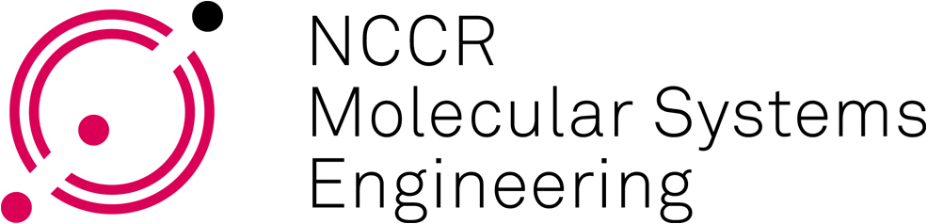
Every employee funded by or associated with the NCCR MSE project, is requested to complete this form. We must ensure that everyone who is involved in the NCCR MSE project is entered in the NIRA database.

Personal data: OTHER STAFF (Administrative/Technical Staff)

General
Employee number (Uni Basel employees only)
Family name: |  |  |  | *
First name(s): |  |  |  | *
Gender: |  |  |  | *
Employer:
Nationality 1: |  |  |  | *
Nationality 2 (if applicable): |  |  |  | *
Date of birth (dd/mm/yyyy): |  |  |  | *
Institute
Laboratory: |  |  |  | *
Institute/Department: |  |  |  | *
Institution (University): |  |  |  | *
Website of research group: |  |  |  | *
Address: Street, No: |  |  |  | *
ZIP / Place: |  |  |  | *
Communication
Phone business: |  |  |  | *
Phone mobile: |  |  |  | °
Business email address: |  |  |  | *
Private address
Private address: Street, No: |  |  |  | *
Postcode, Place: |  |  |  | *
Country: |  |  |  | *
Degree and function of the employee
Degree / Profession: |  | *
Origin of degree (name/place of institution): |  | *
Since (year) |  | *
Project (state SAP number - NCHXXXX): |  | *
Function: | Other staff | *
Start with the NCCR MSE Project: |  | *
End of employment (if before 30 June of current year): |  | *
Activity rate for the NCCR MSE in %: |  | *
*** Funding – this must be completed, thank you. Incomplete forms will be REJECTED***
Cash funding, charged to your project: | pls tick, if appropriate |  | *
In-kind funding, NOT charged to the project: | pls tick, if appropriate |  | *
SNF (NCCR MSE) in %: |  |  | *
Self-Funding Home Institution in %: |  |  | *
Self-Funding Groups in %: | Source: |  | *
3rd Party Funding in %: | Source: |  | *
Date: |  |  | *

IF ANY OF THESE DATA CHANGE PLEASE LET US KNOW. * = mandatory ° = for administration

