From molecular modules to machines to factories and Cells
Authors
Address

Please use A0 template to prepare your poster

Abstract
We develop, optimize and apply methods to program nanoscopic reaction compartments, vesicles, nanocontainers, nanoreactors, organelles, cells, tissues and organs with functional molecular modules. As this project has he goal to integrate molecular modules into synthetic or biological systems which all are engineered within the NCCR it is highly interdiscipiplinary and crosses chemical, biological, engineering, systems oriented and nanotechnological disciplines.

Project in the Context of the NCCR
This can be viewed as the introduction
What is the grand question that you are trying to address and how does it relate to molecular factories or controlling cellular systems?
Which fundamental systems-related question(s) you are addressing, how they integrate into and how they contribute to the NCCR.

Added Value and Collaborations
What is the added value for your project to be part of the NCCR?
Please outline what component (molecular module or molecular system) you obtain from another group of the NCCR and is the module or system you produce used by another NCCR member?
List a) with whom you collaborate and b) how does the NCCR profit from your unique expertise.

Results
Subtitle (if needed) Capitalizing the First Letters
Report the results of your NCCR project.

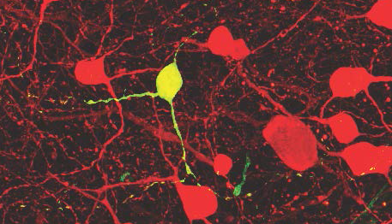
Figure 1. Targeted single cell infection by combining virus stamping. A single tdTomato-expressing retinal ganglion cell was targeted for virus stamping in a retina in which melanopsin-expressing ganglion cells are labeled with tdTomato (Opn4-Cre × Ai9 mice). Stamping with G-deleted rabies virus encoding GFP resulted in a single ganglion cell that was labeled with both GFP and tdTomato.^{[1]}
Challenges Ahead
This is a separate section for the challenges, which can be viewed as conclusion/outlook.
Please emphasize whom within the NCCR will profit from your contribution.

Publications resulting from the NCCR
- R. Schubert, K. Balint, S. Trenholm, M.A. Mohr, D. Martinez-Martin, J. Jüttner, R. Newton, K. Yonehara, A. Ponti, A. Ghanem, K.-K. Conzelmann, D.J. Müller, B. Roska, "Virus stamping for targeted single cell infection in tissue and cell culture", in revision.
- J. Thoma, B.M. Burmann, S. Hiller, D.J. Müller, "Impact of holdase chaperones Skp and SurA on the folding of β-barrel outer membrane proteins", Nat. Struct. Mol. Biol. 22, 795 (2015).
- Use CASSI journal abbreviations, use DOI if article is accepted but with no page numbers

Other references
[4] Include papers (by other groups) relevant to the understanding of the poster

